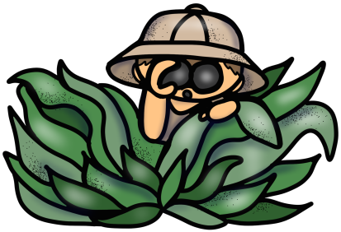
Mrs. Seagondollar

Hello! I’m Mrs. Seagondollar. I graduated from N.C. State University, and earned my teaching certificate through Meredith College. This is my 17th year in education, 11 of those years at Conn. I have also taught 3rd and 4th grade in Franklin County and worked in Special Education. I am on our Media Technology Advisory Committee at Conn and presented at the NC Technology in Education Society (NCTIES) Conference. I am also a mentor to new teachers.

In my free time I enjoy helping at my church, spending time with family, reading, scrapbooking and painting. My husband and I have 2 teenagers, one in high school and one in college. We both grew up in Raleigh and have been part of WCPSS since 1st grade!
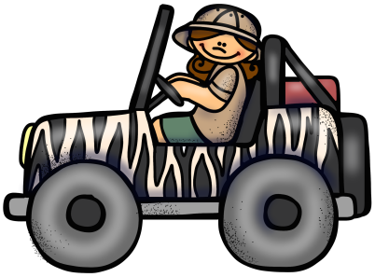
Follow our class on Twitter @WildN4th

I can be reached at wseagondollar@wcpss.net.

